A professional development opportunity for 4-H staff, adult volunteers, and teen leaders!

Best practices in animal care and positive youth development
Introduction to new Animal Science Curricula

Topics include: Animal Welfare; Livestock/Predator Interactions; Dog Care & Training

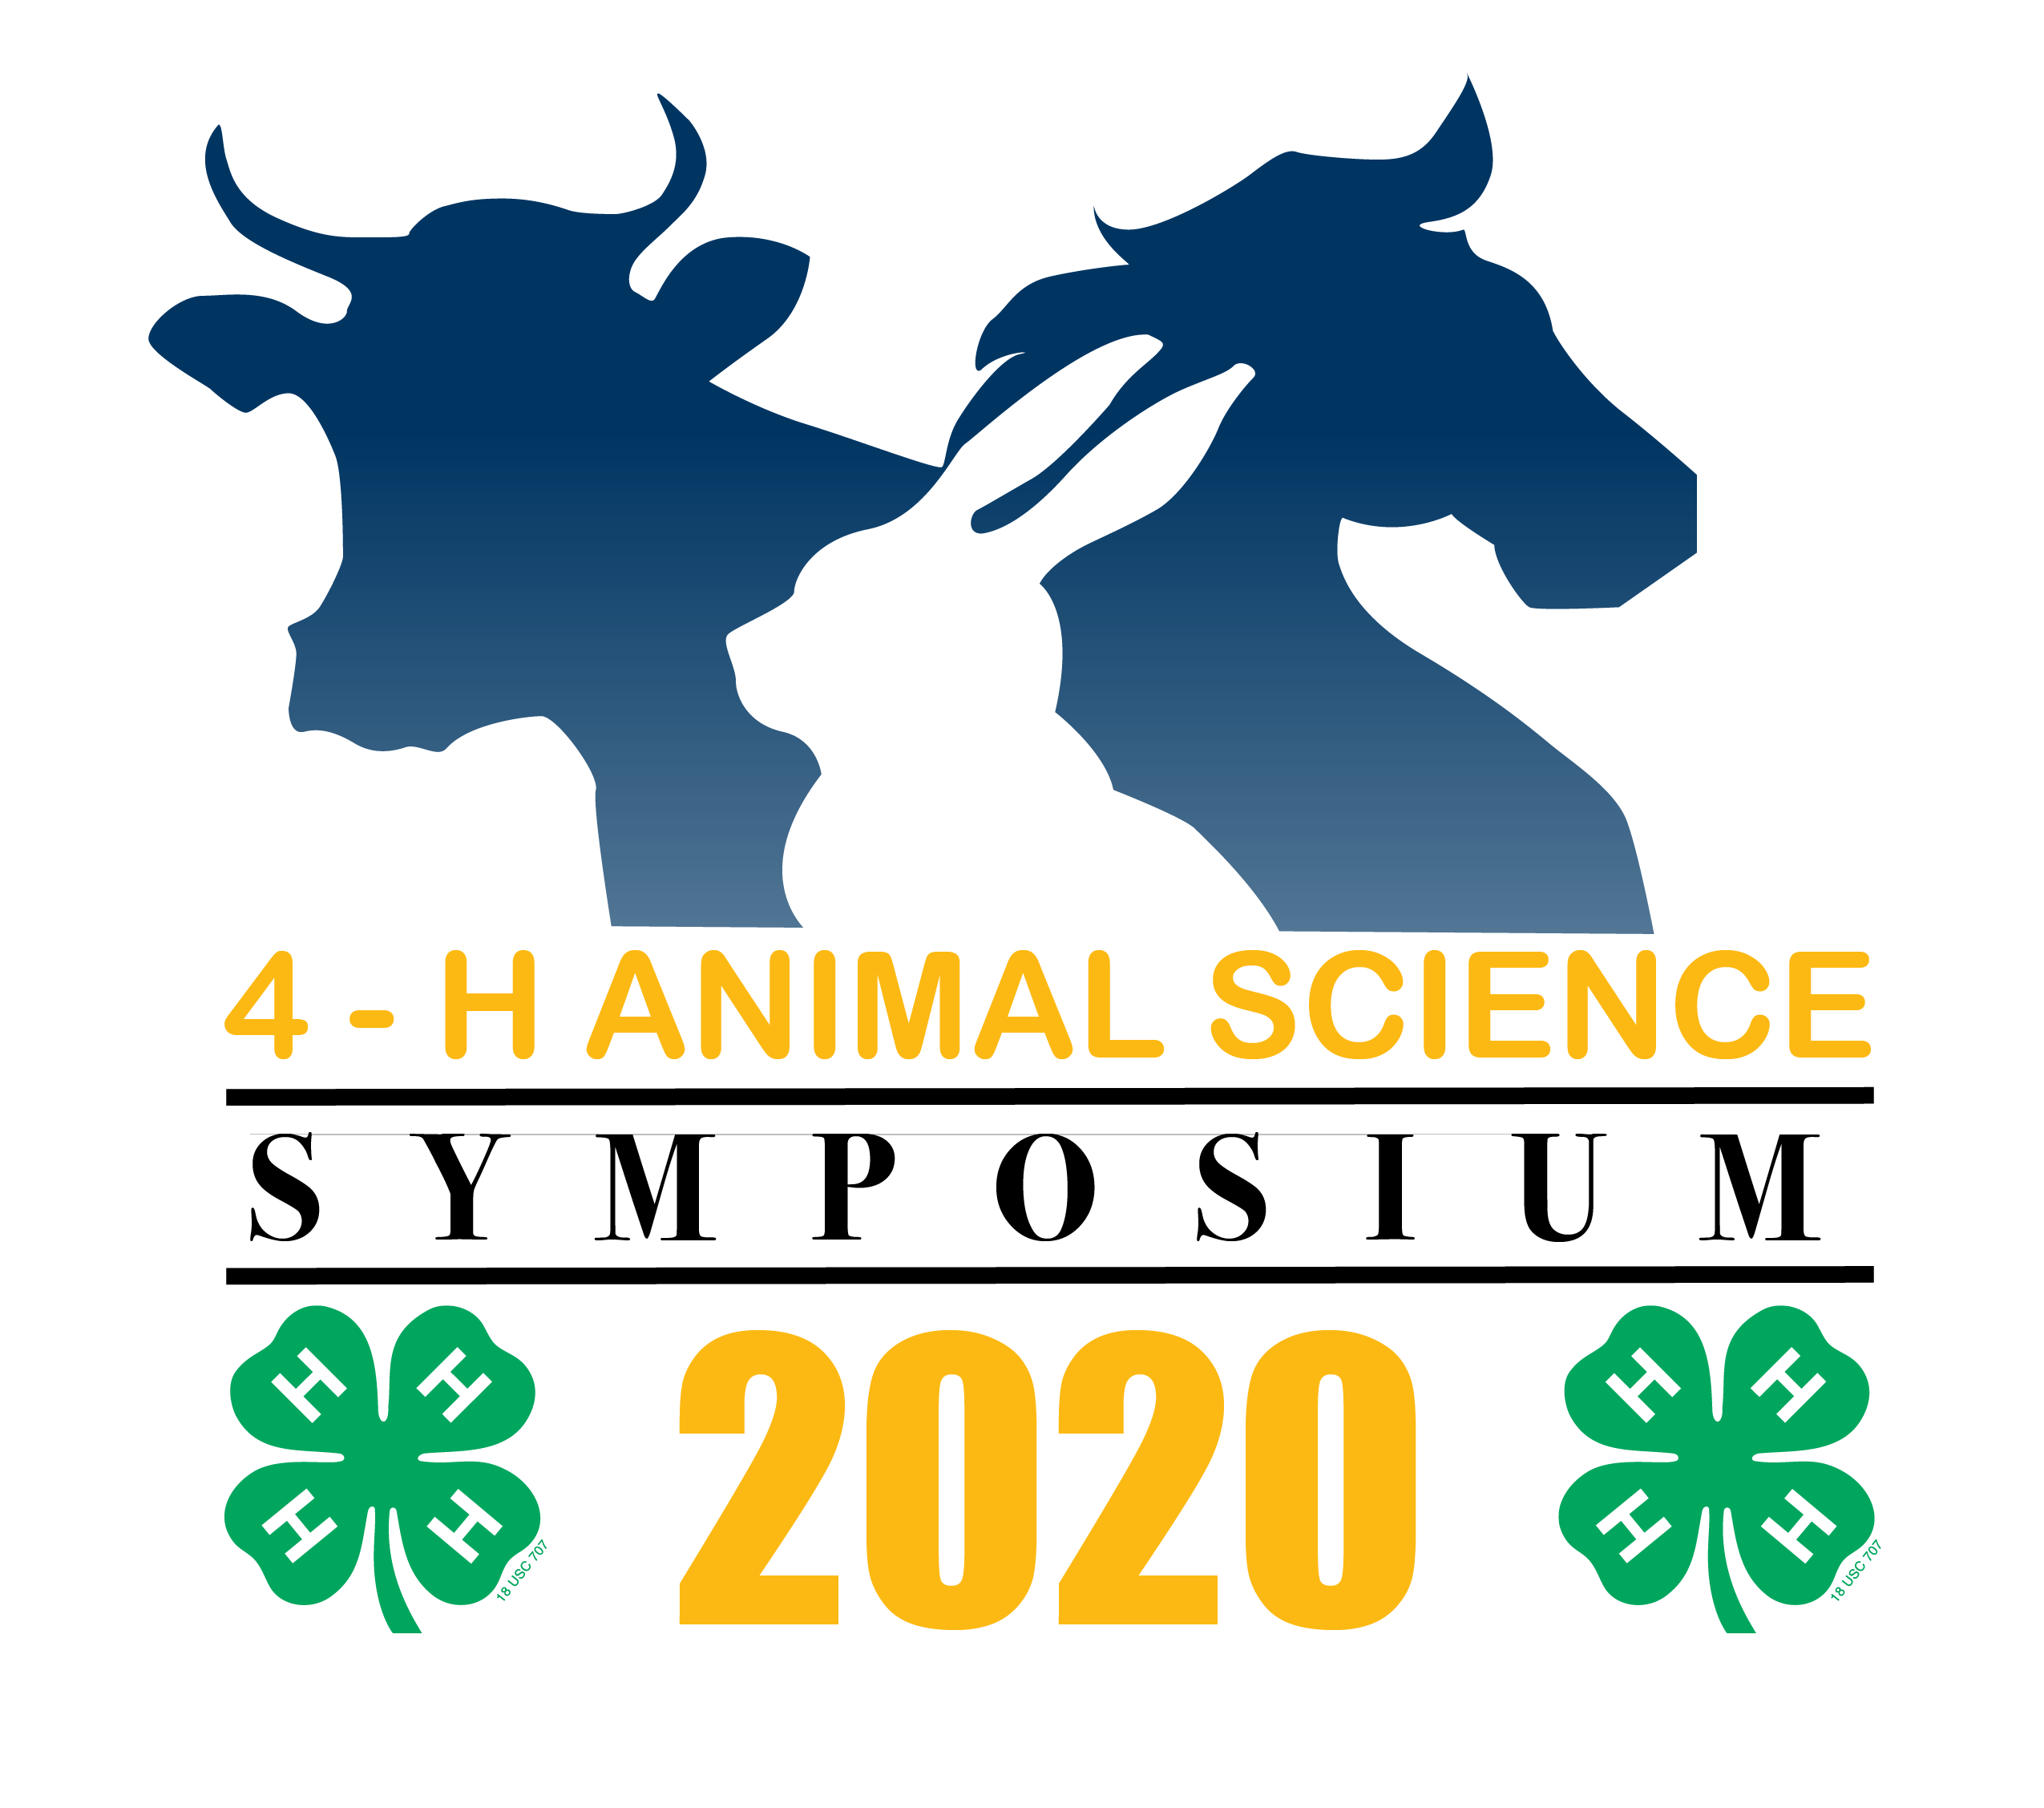
“Tuesdays in June”
Zoom Platform
- June 2nd: Animal Welfare Proficiencies in 4-H
- Pre-registration required: https://ucanr.zoom.us/meeting/register/tJUucOuhrDstG9TKI3b4e9-5dqtTI83ICERU
- June 9th: At the Interface Between Livestock and Predators
                - Pre-Registration Required: https://ucanr.zoom.us/meeting/register/tJwqdu6tqDkjHdLBw9IiuSv-fFftIfVxWnK3
- June 16th: A ‘Fear-Less’ Approach to Understanding Dogs, their Care, and Training
- Pre-registration required: https://ucanr.zoom.us/meeting/register/tJYld-GqrDMiE9N1Af0H32sAY9AtAg3Vdhd7
For more information, please contact:
Lynn Schmitt-McQuitty, lschmittmcquitty@ucanr.edu
No Registration Fee!
Space is limited!

Symposium Highlights:
- Interactive and informative sessions
- Introduction to effective teaching methods
- Overview and availability of new curriculum materials
- Guest speakers include Dr. Melissa Bain, Dr. Niamh Quinn, Dr. Carolyn Whitesell, Dr. Cheryl Meehan, Mr. Dan Macon, and Dr. Brian Greco.

It is the policy of the University of California (UC) and the UC Division of Agriculture & Natural Resources not to engage in discrimination against or harassment of any person in any of its programs or activities (Complete nondiscrimination policy statement can be found at http://ucanr.edu/sites/anrstaff/files/215244.pdf ) Inquiries regarding ANR’s nondiscrimination policies may be directed to John I. Sims, Affirmative Action Compliance Officer/Title IX Officer, University of California, Agriculture and Natural Resources, 2801 Second Street, Davis, CA 95618, (530) 750-1397.

